CENWP-OD-B 07 September 2022

MEMORANDUM FOR THE RECORD

SUBJECT: 22BON087 MFR AFF Valve 15 Salmonid Mortality

On 07 September, Columbia River Inter-Tribal Fish Commission (CRITFC) Biologists notified Bonneville Project Biologists of one salmonid mortality found on the valve 15 trash rack in the Adult Fish Facility (AFF). The fish was scanned for PIT tags, inspected, and returned to the river.

- Species – Salmonid Spp.
- Origin – Unknown
- Length – 84.5 cm
- Marks and tags – None
- Marks and Injuries found on carcass – General decay
- Cause and Time of Death – Unknown.
- Future and Preventative Measures – None
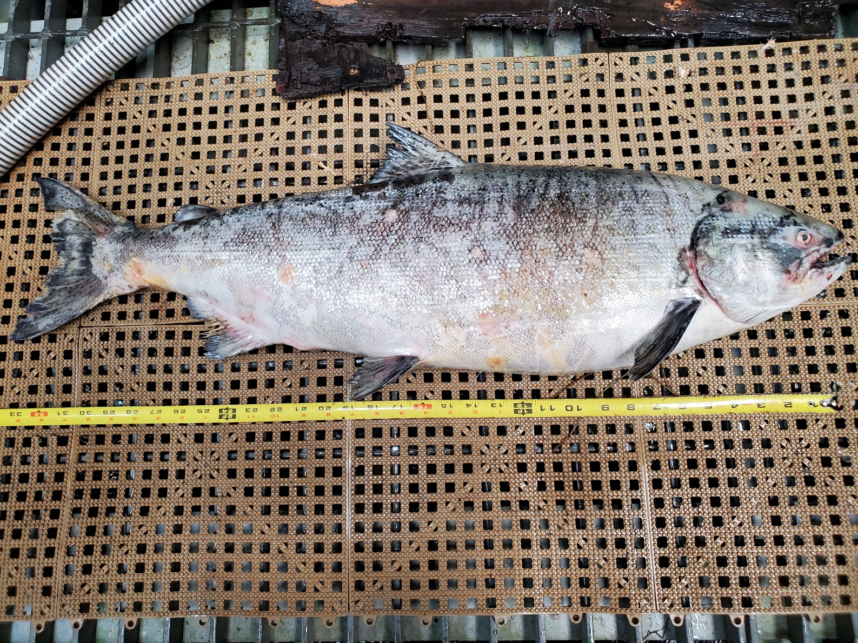

Sincerely,
Bonneville Project Fisheries

